ARI 410/510 Problem Set Guidelines
University of Michigan-Flint – Fall 2026
(See course Canvas page for due date)

What to do
There are several stages we will go through for these problems:
Solo: Complete the problems on your own and submit your answers before the start of class on the due date. Graded on completion and effort. Answer the questions on your own (do not use AI tools to do them for you), for now, based on your understanding of the course material.
Group: At the start of class on the due date, in small groups, come to a consensus about the answers. Remember who you worked with. Graded based on engagement with group members.
Class: For each question, one student will be randomly selected to present and justify the solution. The entire class may ask questions and work together as necessary to reach a solution. Graded based on participation, effort, and demonstrated understanding of the core premises of the problem.
Final submission & Bonus: After class, make a second, updated submission with annotations regarding what changed and why. List the names of the group members you worked with and certify their engagement in the discussion. Some problem sets will have a bonus question that can be completed at this stage. Submit by the “final submission” due date. Graded based on correctness of final answers and thoughtful explanations of changes made.

What to submit to Canvas
Solo submission [first deadline]: A document with your solutions. It can be a copy of this document, or one that only contains your solutions. A PDF editor, word processor, Google Docs, or a photo of neat handwritten work are all fine, as long as your answers are clearly readable.
Final submission [second deadline]: A copy of your Solo solutions with any updates in a visually distinct way (e.g., a different color, or a comment feature), where updates include the change and why you made it. Also attach the completed group-member evaluation (plus answers to any bonus question(s)).

Resources
You may use resources from class or online, but the answers you submit must represent your own work and effort. Do not use generative AI tools to directly answer the questions for you. It is fine to ask an AI for explanations of concepts (e.g., “what is the difference between a weight and a bias term?”) or for reference information. But for a problem that asks you to derive or compute something, having an AI produce that derivation or computation counts as directly answering it. In the end, you need to be able to solve the problem on your own.

Other notes
Questions / Clarifications: ask in class or on Discord (#homework-help). Demonstrating effort: showing the steps you followed may be required to receive credit. Assumptions: if you need to make a reasonable assumption about something unclear, state it in your answer. Levels: most problems are shared. Where a problem forks, a [410] and a [510] marker show each track; do the one for your section. (410 students are welcome to attempt the 510 version and include it.)

Problem Set 3: Lake Watch 🌊
Harmful algal blooms turn parts of Michigan’s lakes green every summer, and some produce toxins that make the water unsafe to drink or swim in. A team of environmental scientists wants machine learning tools that can warn communities before and during a bloom.

Problem 1. A tiny random forest
The team has records from 10 past summer days (training days 1 to 10), each with three features: water temperature (°C), phosphorus level (µg/L), and wind speed (km/h), plus whether there was a bloom. They trained a random forest of three decision trees. Each tree was trained on its own sample (with replacement) of the 10 days and was only allowed to use two of the three features:
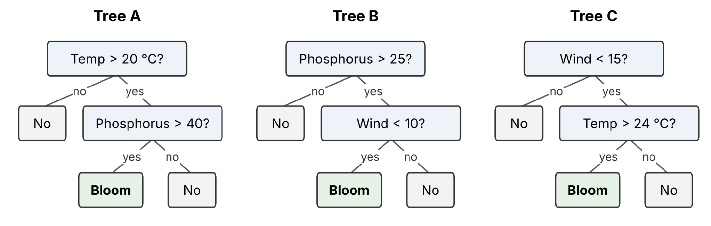
Thresholds use the same units as the table of days below; “No” means no bloom.
Tree | Features it uses | Training days in its sample
A | Temperature, phosphorus | 2, 2, 3, 5, 6, 6, 7, 9, 9, 10
B | Phosphorus, wind | 1, 1, 3, 4, 4, 5, 8, 8, 9, 10
C | Wind, temperature | 1, 2, 2, 3, 6, 7, 7, 7, 8, 10
Here are six new days the classifier has never seen:
Day | Temperature (°C) | Phosphorus (µg/L) | Wind (km/h) | Actual
1 | 27 | 30 | 5 | Bloom
2 | 28 | 55 | 12 | Bloom
3 | 26 | 15 | 6 | No bloom
4 | 23 | 50 | 20 | No bloom
5 | 22 | 60 | 4 | Bloom
6 | 18 | 35 | 5 | No bloom

(a) Follow each tree to get its prediction for each day, and fill in the table. Then combine them by majority vote. What is the accuracy of each tree on its own, and of the vote?
Day | Tree A | Tree B | Tree C | Majority Vote | Actual
1 | No Bloom | Bloom | Bloom | Bloom | Bloom
2 | Bloom | No Bloom | Bloom | Bloom | Bloom
3 | No Bloom | Bloom | Bloom | Bloom | No bloom
4 | Bloom | No Bloom | No Bloom | No Bloom | No bloom
5 | Bloom | No Bloom | No Bloom | No Bloom | Bloom
6 | No Bloom | No Bloom | No Bloom | No Bloom | No bloom

Tree A Accuracy: 66%
Tree B Accuracy: 50%
Tree C Accuracy: 66%
Majority Vote: 66%

(b) Why is the vote so much more accurate than any single tree? (Look at which days each tree gets wrong.)
Tree B was the least accurate Tree with 50%, the other two trees performed just as well as the majority, each coming in at 66%. The majority is more accurate than Tree B because it works to reduce the noise created by erroneous tree formation by taking the average guess of all 3 trees instead of weighing one individual contributor.

(c) Suppose instead that all three trees had been trained on all 10 days, each allowed to use all three features. What would the three trees most likely look like (describe this based on your understanding of how decision trees are learned, don’t calculate exactly), and what would that do to the benefit of voting? Why does limiting each tree to a random subset of features help?
The trees would be identical to themselves if their training samples were the same and their feature selections were the same as well. This would harm the voting process because it would eliminate the point of having multiple random trees to reduce the noise by any one tree. The trees would also decide on the most significant variable to split on first which is very biased and creates a dominant component in the feature set. Having random subsets forces the trees to be diverse and attack the problem in different ways. When these trees average together, all their errors tend to cancel each other out and results in a good classification. Also, it helps the model generalize by not overfitting to specific feature combinations on the dataset.

(d) Boosting also combines several weak models, but it trains them one after another instead of independently. If Tree A were the first model in a boosted ensemble, which of these six new days should the second model focus on, and why?
The model should focus on Days 1 and 4. During prediction the model predicted these 2 days incorrect. In boosting the model will look at the probability of this guess and subtract that from 1 to train the next tree. From there Tree 2 will adjust its weights to correct for the mistake in probability and then the guesses will be added together and passed through a sigmoid function to return a final probability for the new prediction based on both trees input.

Problem 2. Neural network
The team builds a tiny neural network that predicts the probability of a bloom from two standardized features: x₁ = water temperature and x₂ = phosphorus level. It has one hidden layer with two Rectified Linear Units (ReLU; a simple but popular piecewise activation function, defined below) and a sigmoid activation for the output:
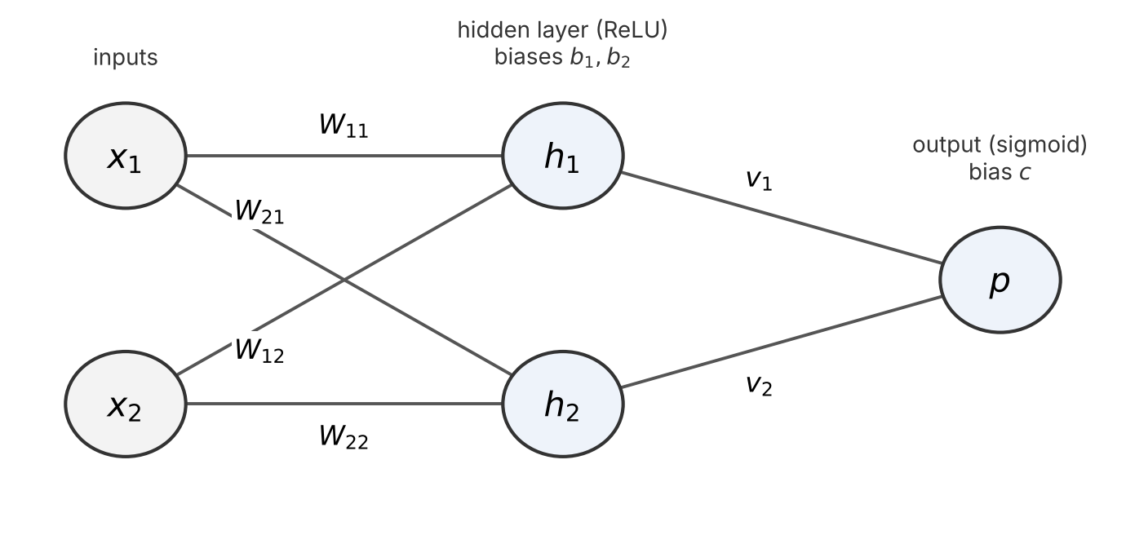
Forward pass. For each hidden unit j = 1, 2:
a_{j} = W_{j1} x₁ + W_{j2} x₂ + b_{j}, then h_{j} = ReLU(a_{j}) = max(0, a_{j})
Then the output and the loss:
z = v₁ h₁ + v₂ h₂ + c, p = σ(z) = 1 / (1 + e^{−z}), L = −[ y ln(p) + (1 − y) ln(1 − p) ]
Backward pass. Using the chain rule, as in class (the first line is the same gradient you used for logistic regression in Problem Set 1):
- ∂L/∂z = p − y
- ∂L/∂v_{j} = (∂L/∂z) h_{j}, ∂L/∂c = ∂L/∂z
- ∂L/∂h_{j} = (∂L/∂z) v_{j}
- ∂L/∂a_{j} = (∂L/∂h_{j}) × ReLU′(a_{j}), where ReLU′(a) = 1 if a > 0 and 0 otherwise
- ∂L/∂W_{jk} = (∂L/∂a_{j}) x_{k}, ∂L/∂b_{j} = ∂L/∂a_{j}
Bias terms. Treat each bias like a weight whose input is always 1. Its gradient is then the gradient at that unit times 1, which is why ∂L/∂c = ∂L/∂z and ∂L/∂b_{j} = ∂L/∂a_{j}.
Values. One lake-day with x = (1, 2) (warmer than average, very high phosphorus) had a bloom, so y = 1. The current parameters are:
W₁₁ = 1 | W₁₂ = 0.5 | b₁ = 0 | v₁ = 0.5
W₂₁ = −2 | W₂₂ = 0.5 | b₂ = 0 | v₂ = 1
 |  |  | c = −1
Use learning rate η = 0.1. You may use ln(0.5) ≈ −0.693.

(a) Forward pass. Compute a₁, a₂, h₁, h₂, z, p, and the loss L.

(b) Output layer gradients. Compute ∂L/∂z, ∂L/∂v₁, ∂L/∂v₂, and ∂L/∂c.

(c) Hidden layer gradients. Compute ∂L/∂h₁, ∂L/∂h₂, ∂L/∂a₁, ∂L/∂a₂, then all four ∂L/∂W_{jk} and both ∂L/∂b_{j}.

(d) Update. Take one gradient-descent step on every parameter (θ ← θ − η ∂L/∂θ) and report the new values.

Problem 3. Finding the shoreline
To map how far a bloom has spread, the team first needs to find where the water ends and the land begins in satellite images. Here is a tiny 5 × 5 grayscale patch of an image, where 0 is dark (water) and 3 is bright (land):
0 | 0 | 3 | 3 | 3
0 | 0 | 3 | 3 | 3
0 | 0 | 3 | 3 | 3
0 | 0 | 0 | 3 | 3
0 | 0 | 0 | 3 | 3
They apply this 3 × 3 kernel (filter):
−1 | 0 | 1
−1 | 0 | 1
−1 | 0 | 1
(a) Apply the kernel to the image with stride 1 and no padding: at each position, multiply the kernel by the 3 × 3 patch of the image underneath it, element by element, and add up the results. Compute every value in the output. (You do not need to write out every individual multiplication step)

(b) Where in the output are the values largest, and where are they zero? In words, what is this kernel detecting? How could this help the team find the shoreline?

(c) The real satellite images are 64 × 64 pixels. For an n × n input, a k × k kernel, stride s, and padding p, the output is ⌊(n + 2p − k) / s⌋ + 1 pixels on each side (⌊ ⌋ means round down since we cannot have a fraction of a pixel). Find the output size for a 3 × 3 kernel with:
- stride 1, no padding
- stride 2, no padding
- stride 1, padding 1
Why might the team choose padding 1?

(d) How many numbers would a neural network learn for this one 3 × 3 kernel? Compare that to a fully connected neural network layer that maps a 64 × 64 input to a 62 × 62 output (i.e., one weight for every input-output pair; you can ignore bias terms). What does this tell you about why convolutions are used for images?

